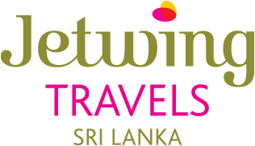

“Jetwing House” 46/21, Nawam Mawatha, Colombo 02, Sri Lanka
Tel: +94 11 234 5700/ 479 0300
Email: sameera@jetwing.lk Website: http://www.jetwingtravels.com/

SERVICE CONFIRMATION VOUCHER
CLIENT’S NAME |  | Mr. Johny Abbas x 2
CONFIRMATION NO |  | JWZMI5910
ARRIVAL |  | 11th FEB | UL 116 CMB 1730 hrs.
DEPARTURE |  | 14th FEB | QR 663 CMB 0400 hrs.
HOTEL | ROOM TYPE |  | CHECK IN | CHECK OUT | MEAL PLAN
CINNAMON BEY | PARADISE SUITE |  | 11th FEB | 13th FEB | HB
MOVENPICK | SUPERIOR CITY VIEW |  | 13th FEB | 14th FEB | HB
NO OF ROOMS |  | 01 DBL ROOM
TRANSPORT MODE |  | A/C CAR WITH THE SERVICE OF AN ENGLISH-SPEAKING CHAUFFUER GUIDE
REMARKS |  | N/A
EMERGENCY CONTACT |  | SAMEERA +9477 347 7786 (24 HOURS)
AIRPORT REP |  | +9477 728 7837 (24 HOURS)

We Wish You A Memorable Stay…!

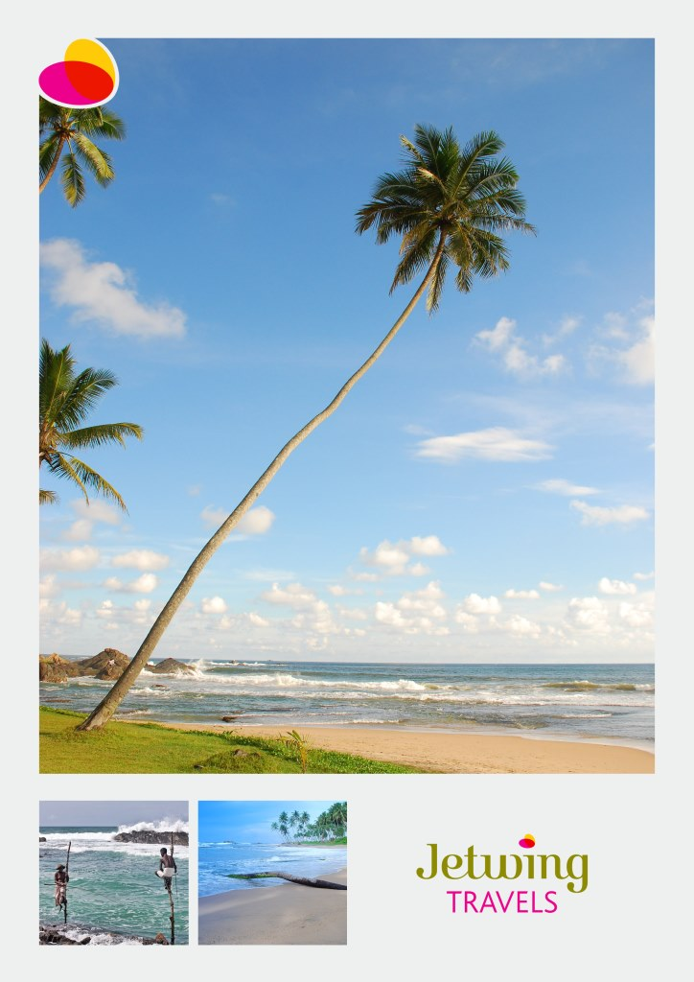

Jetwing Travels (Pvt) Ltd.

“Jetwing House”', 46/26, Navam Mawatha,

Colombo 2, Sri Lanka.
Telephone: + 94 11 2345 700
Fax: + 94 11 2345725 or 2345724
Web site: www.jetwingtravels.com

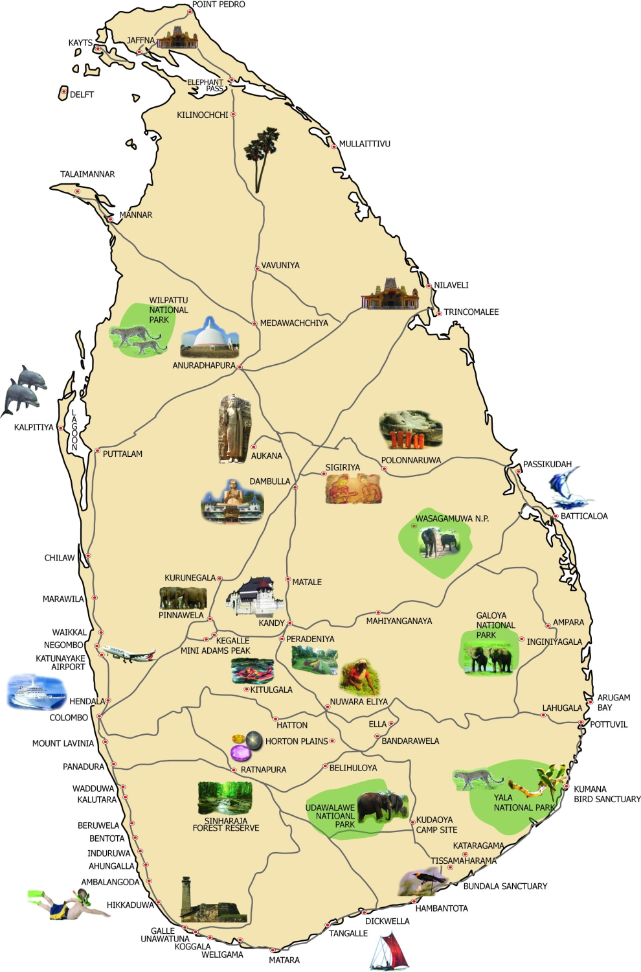

TOUR PROGRAMME

11th February – Airport / Bentota

Arrive in Sri Lanka. You will be met by a representative of Jetwing Travels and Transfer to Bentota.

Spend rest of the day at leisure.

Overnight at Cinnamon Bey, Bentota

12th February – Bentota

Breakfast at the hotel.

Madu River Boat Ride – in the 915-hectare Madu Ganga Estuary is connected by two narrow channels to the Randombe Lake, forming a complex wetland system encompassing 64 mangrove islets. In the year 2000, International Union for the Conservation of Nature (IUCN) undertook a detailed biodiversity survey of the region & revealed the existence of no less than 10 major wetland vegetation types supporting over 300 plant species & 248 species of vertebrates.

On completion do a Bentota City Tour.

Kosgoda Turtle Hatchery – Globally, all seven species of marine turtles are endangered. Of these seven, five come ashore to nest in Sri Lanka. The process of marine turtles nesting, hatchlings being born, and swimming back to sea is fascinating to observe.

Overnight at Cinnamon Bey, Bentota

13th February – Bentota / Colombo

Breakfast at the hotel.

Drive to Colombo & check in to the hotel.

In the Evening do a half day Colombo city & shopping tour

Colombo, like many capital cities in developing countries is fast changing its face. Almost overnight, skyscrapers arise from where old buildings once stood. Yet in some parts, the old world charm is retained with several British built colonial buildings. Other places of interest are a Hindu and a Buddhist temple, residential areas where you find the stately homes of the affluent, the Bandaranaike Memorial International Conference Hall (BMICH)- an outright gift to Sri Lanka from the People's Republic of china and the old parliament. Also visit Dutch-Portuguese Fort area, Mosques, Temple, Churches, The Independence Square and The National Museum.

Also, visit House of Fashions, ODEL, Noritake ceramic shop & a local souvenir shop.
Overnight at Movenpick, Colombo

14th February – Colombo / Airport

Breakfast at the hotel.

Proceed to BIA Airport for your departure flight.

………………………End of the tour………………………

Tour include:
- Accommodation at the above mentioned Hotels or similar on HB basis.
- Transport in an A/C Car on PVT basis with the service of an English-speaking chauffeur Guide
- Value added tax.
- Assistance at the airport.
Tour not include:
- All entrance fees
- Lunches throughout tour.
- Visa & other charges.
- Early check in & late check-out.
- Camera & video permits.
- Cost of beverages.
- Any expenses of a personal nature.
- Any other expenses not mentioned above.
- Tips & Portages.
- Any compulsory room supplements during the tour.

